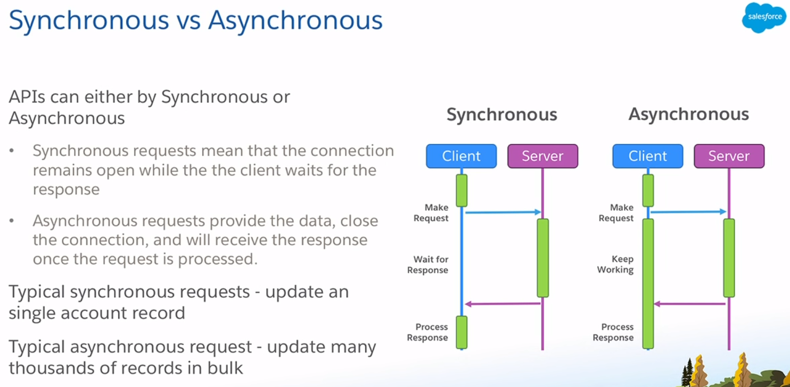

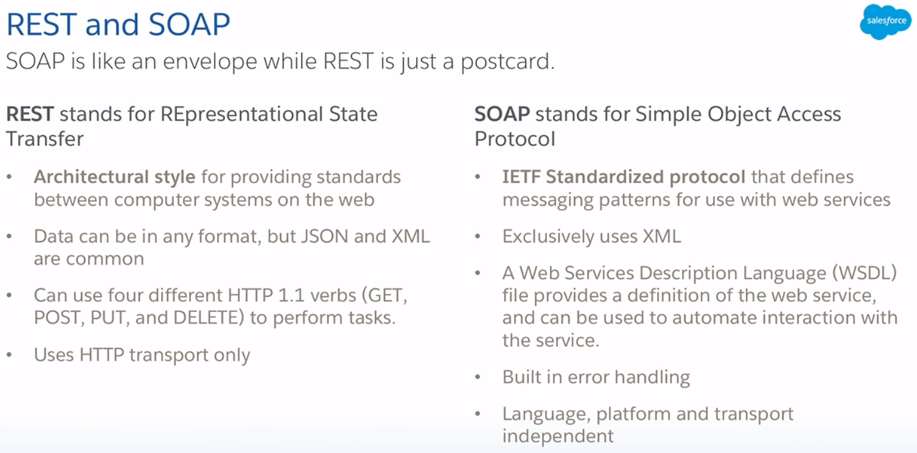

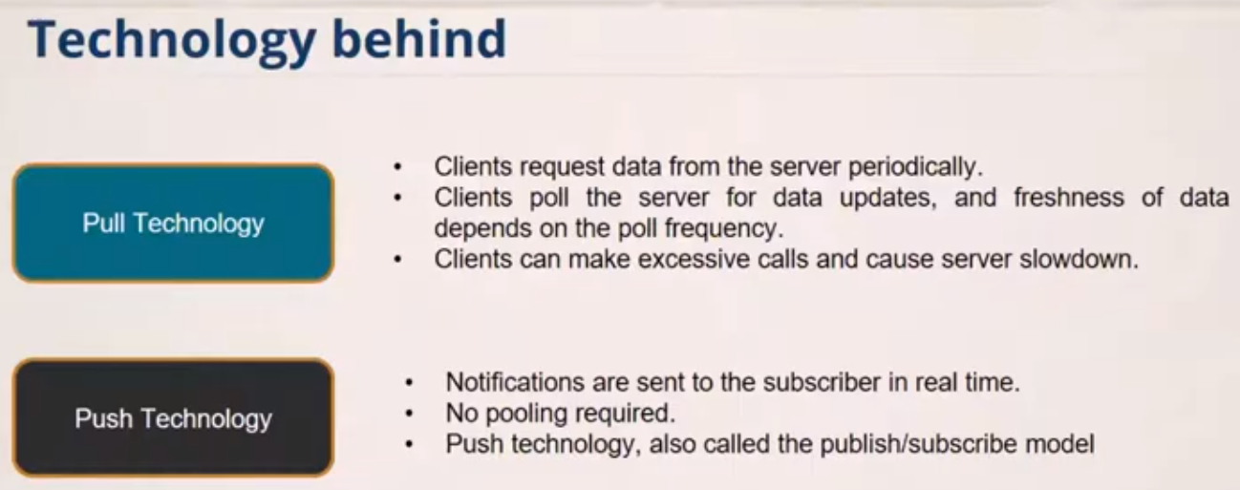

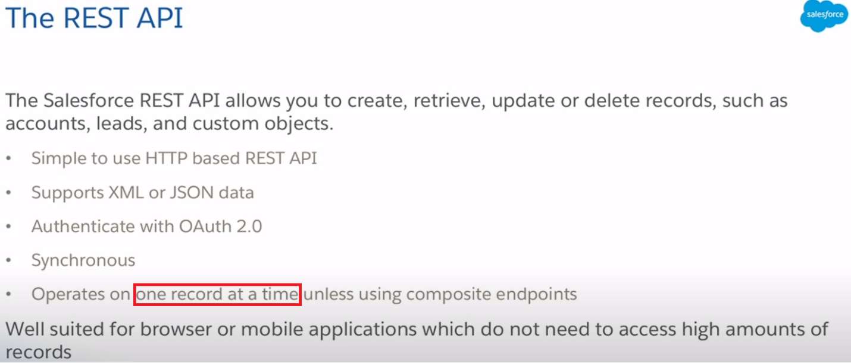

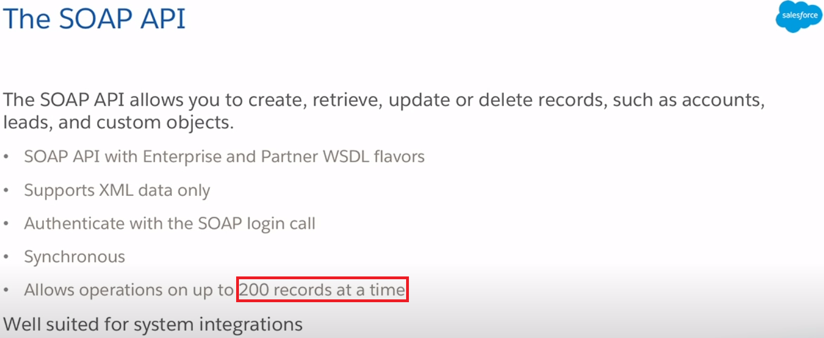

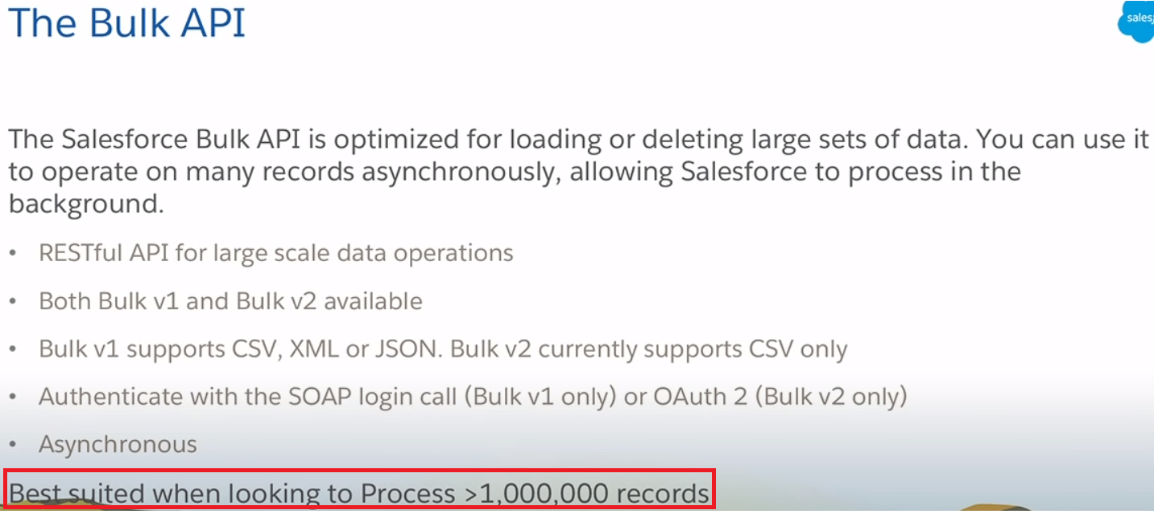

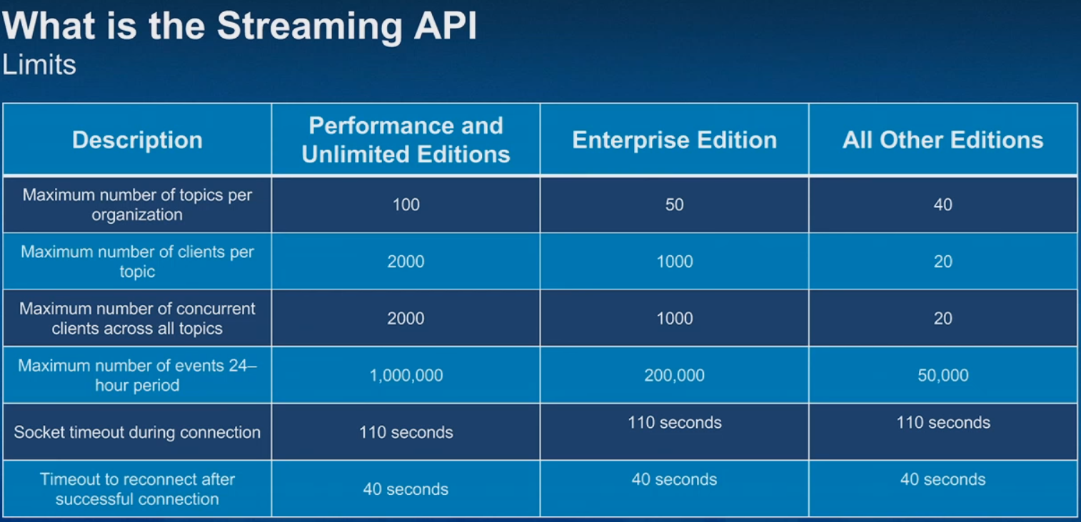

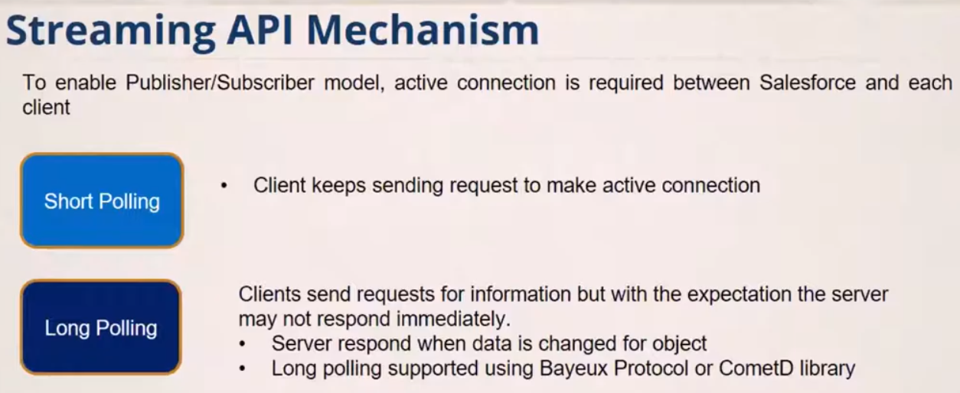

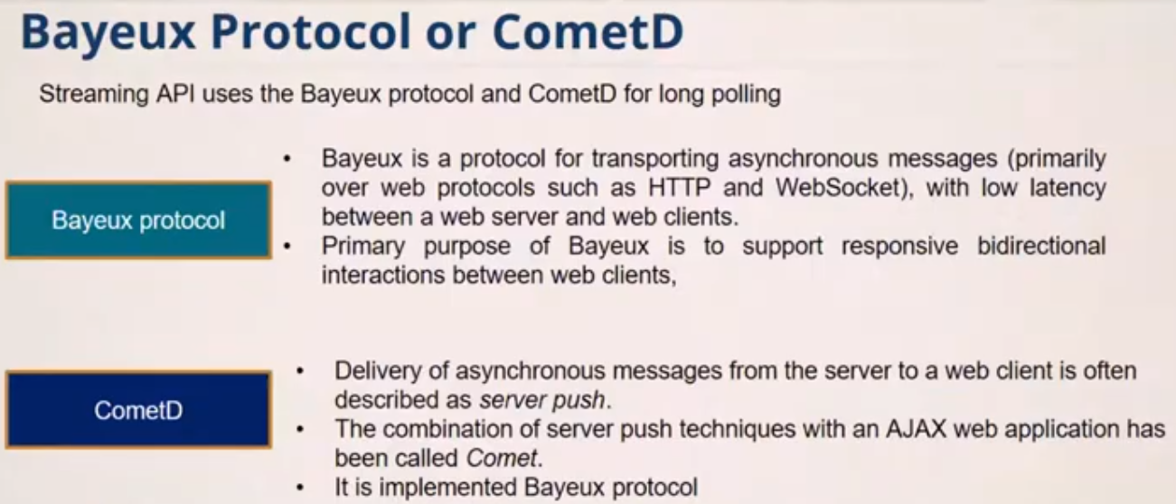

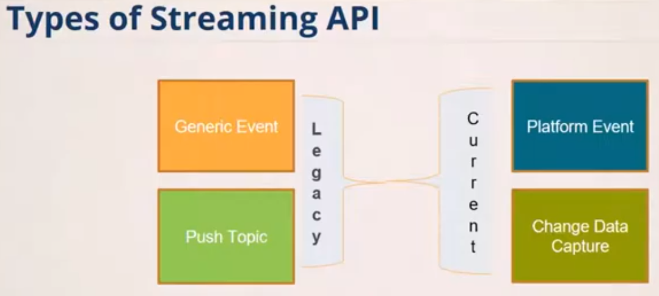

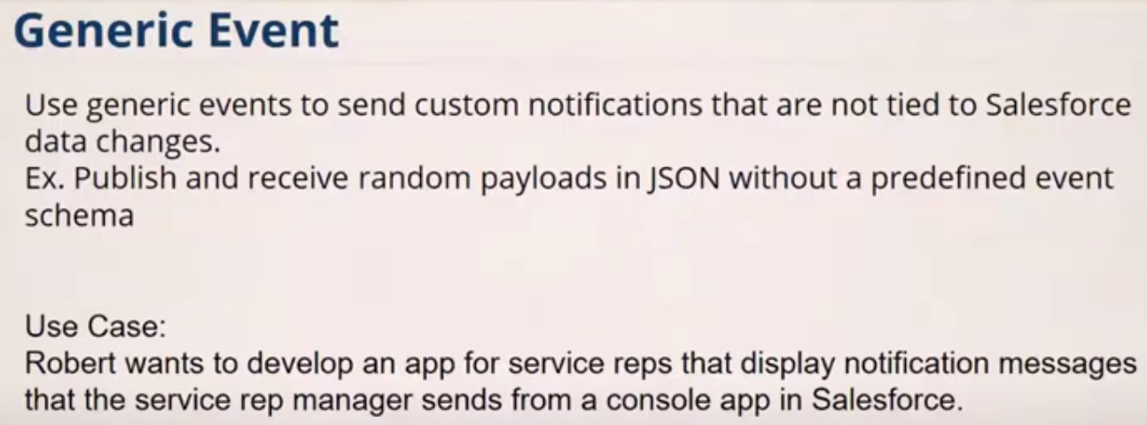

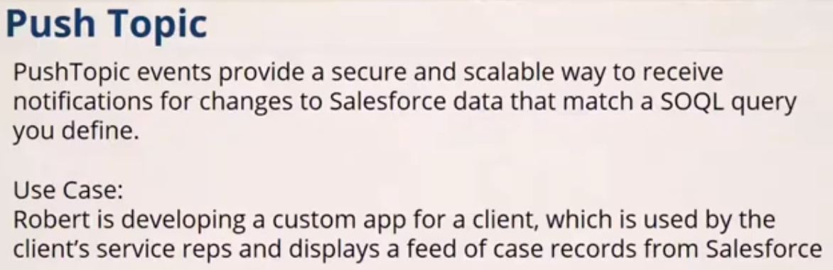

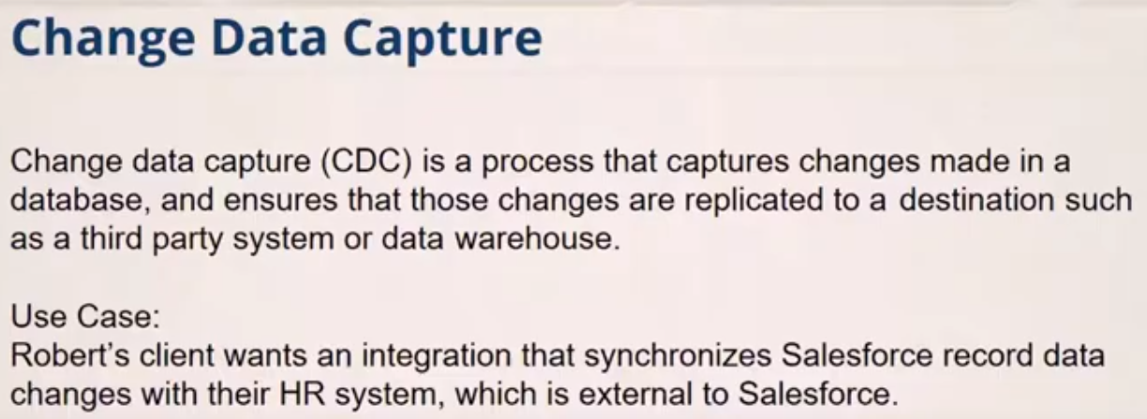

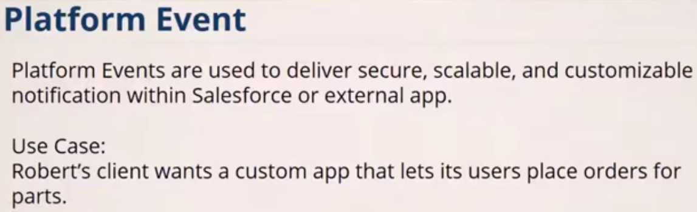

**Example-1**

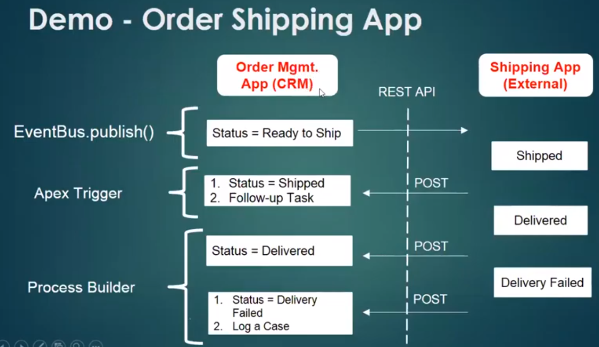

**Example-2**

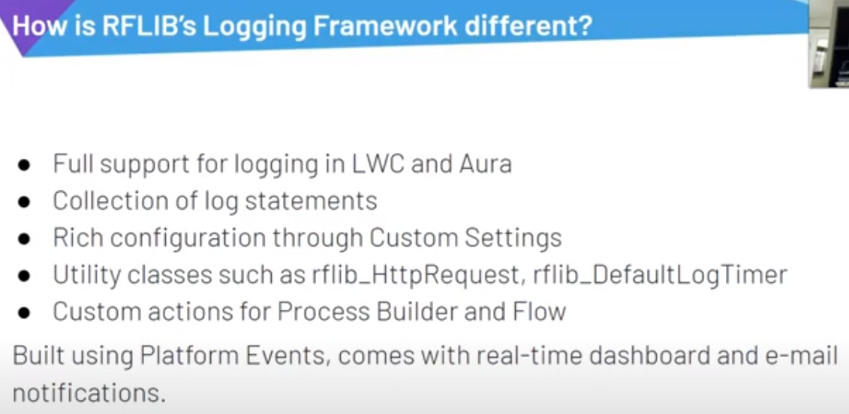

**Another Scenario**

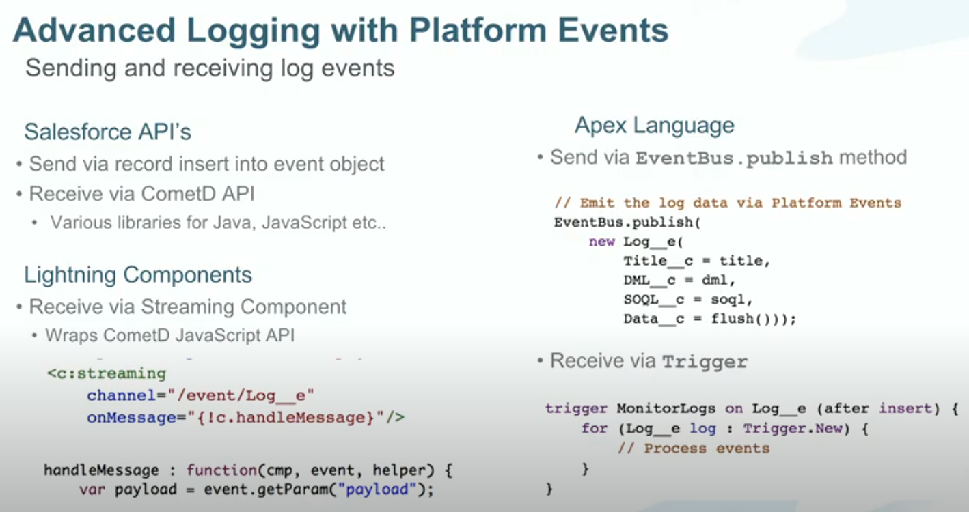

**Example-3**

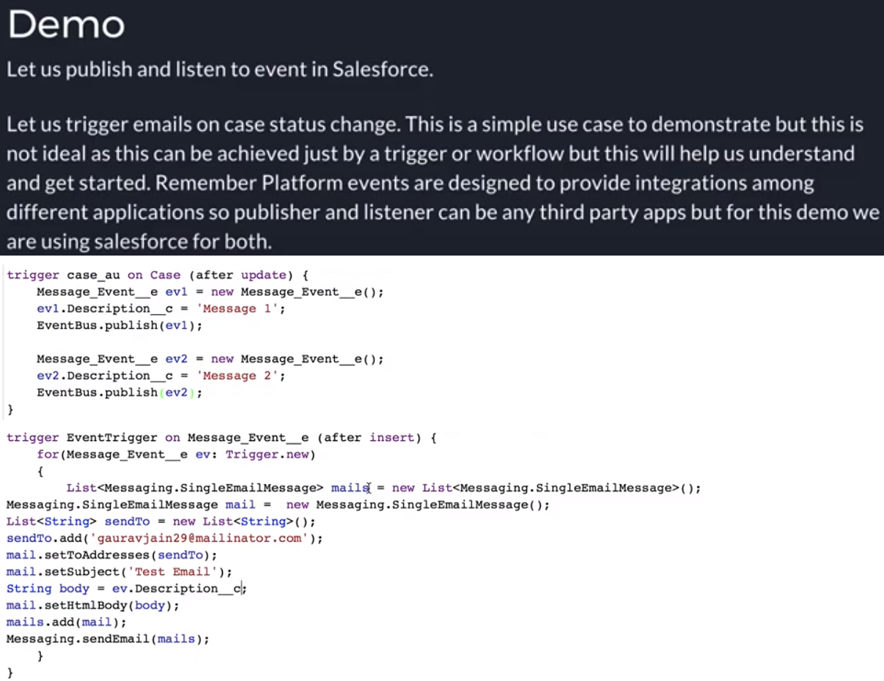

**Example-4:** 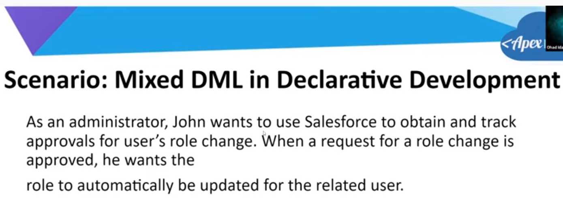

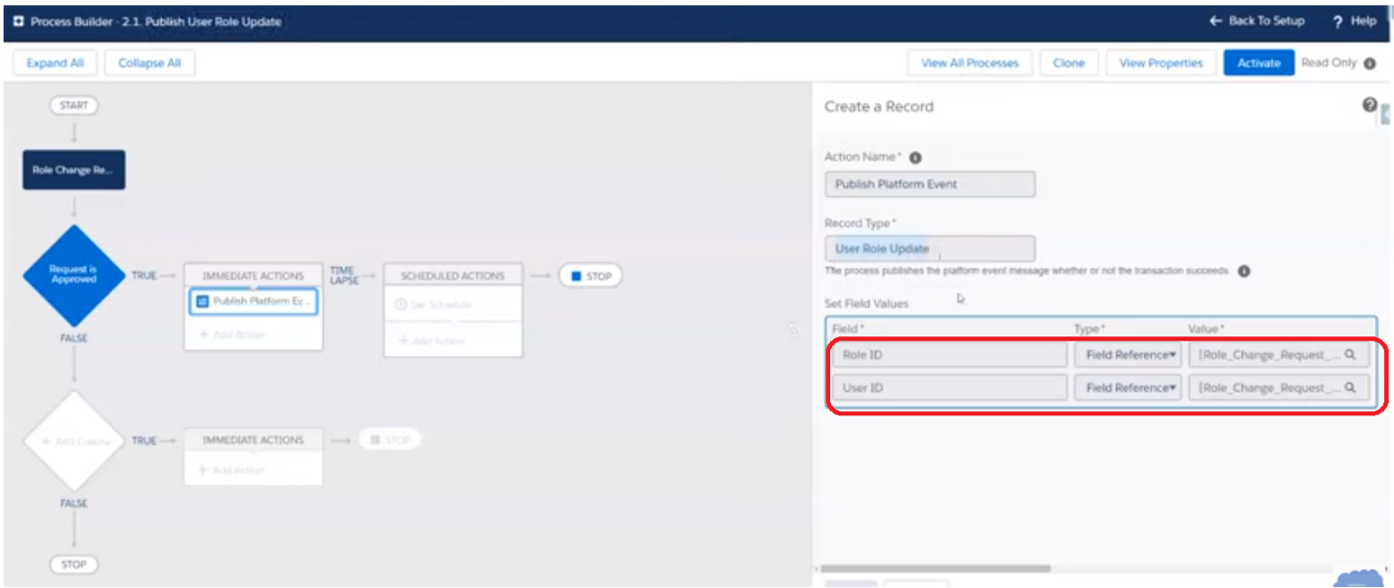

**Solution**: Split into 2 process builders

One for publish and one for Subscribe.

**Example-5:**

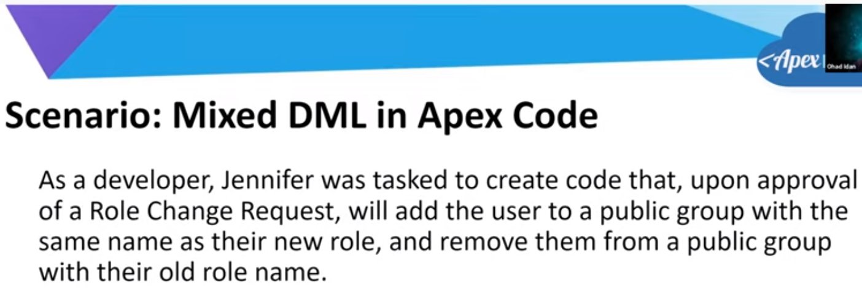

Solution: Publish event through process builder and subscribe using Asynchronous Trigger

**Example-6:**

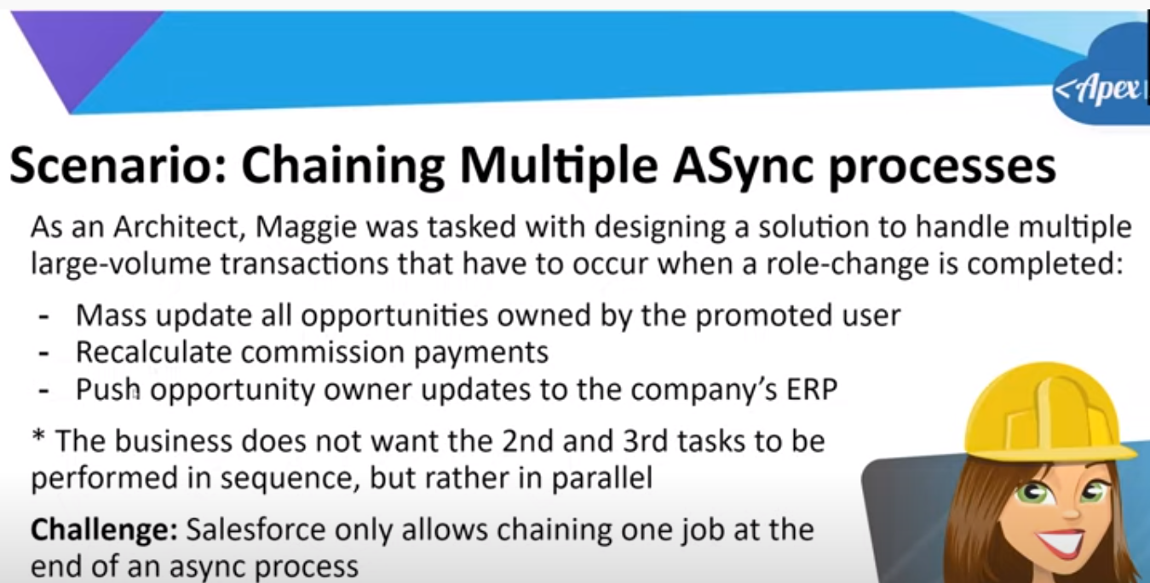

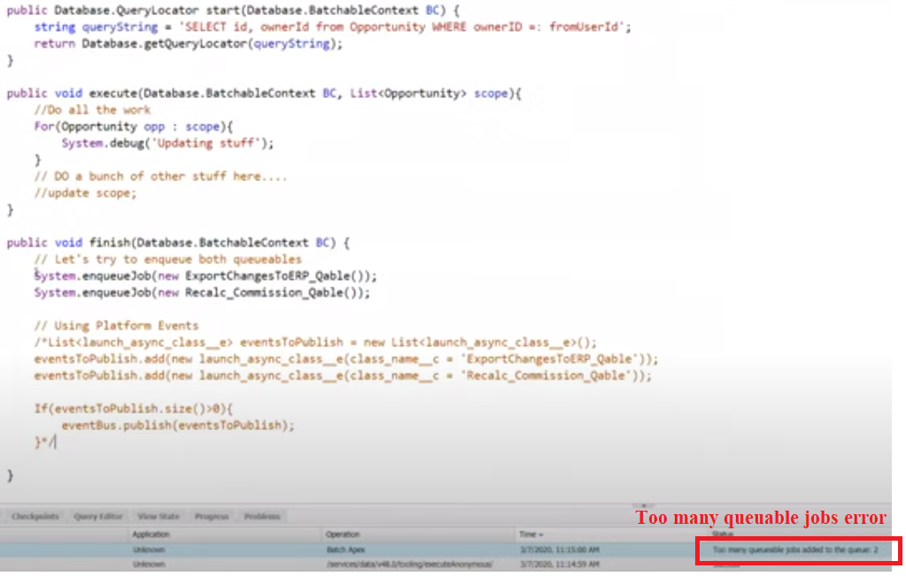

**Example-7:**

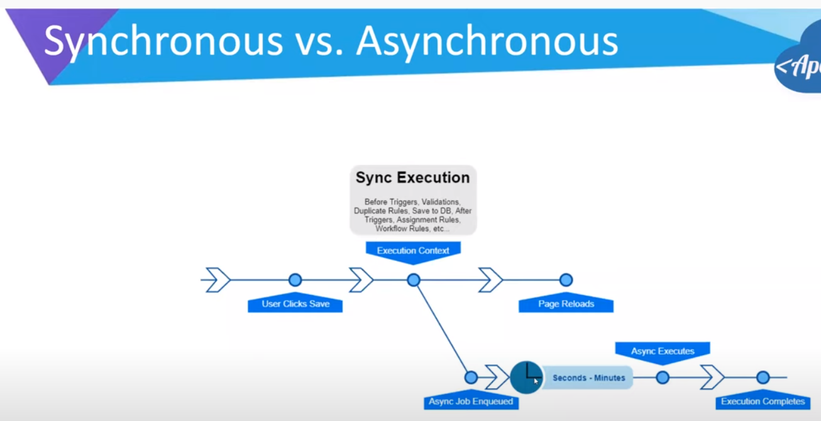

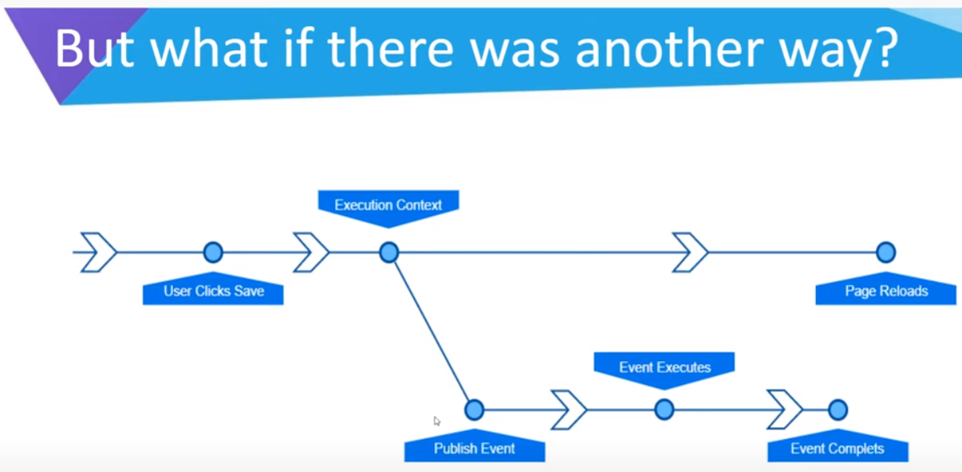

**Example-8**

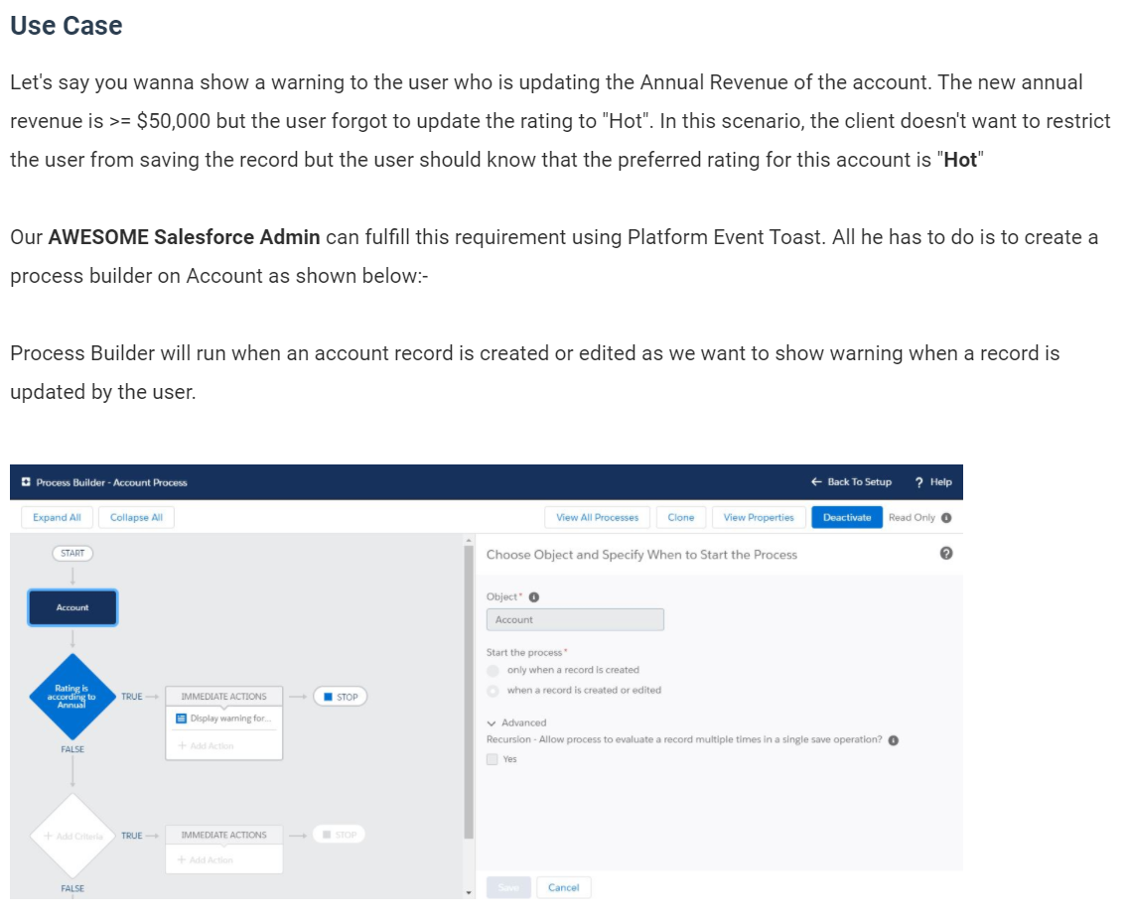

We're setting the criteria that all of the conditions are met and we've added two conditions:-

1. Annual Revenue >= $50,000
2. Rating != Hot

We'll execute the process builder only when the specified changes are made to the record as we want to show warning only once.  
  
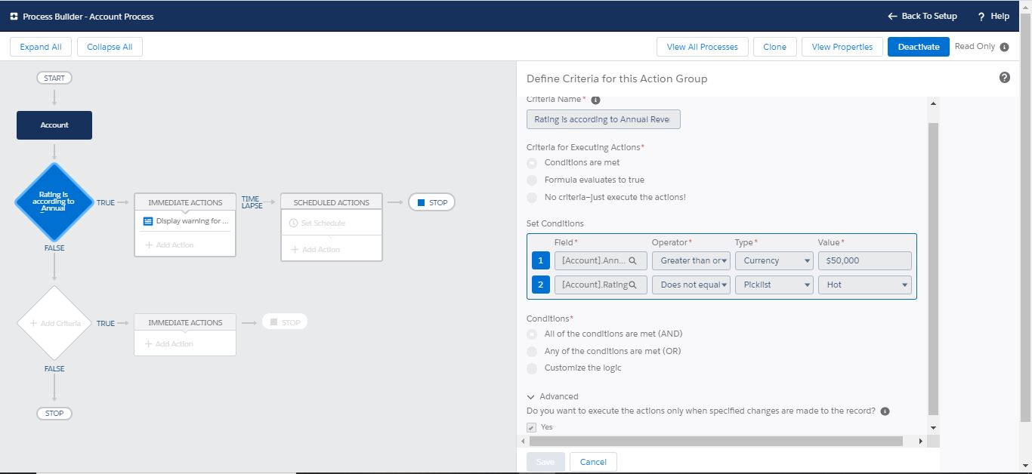  
  
At the end, we added an action where we're creating a Toast Event record by setting up properties of toast as shown below:-  
  
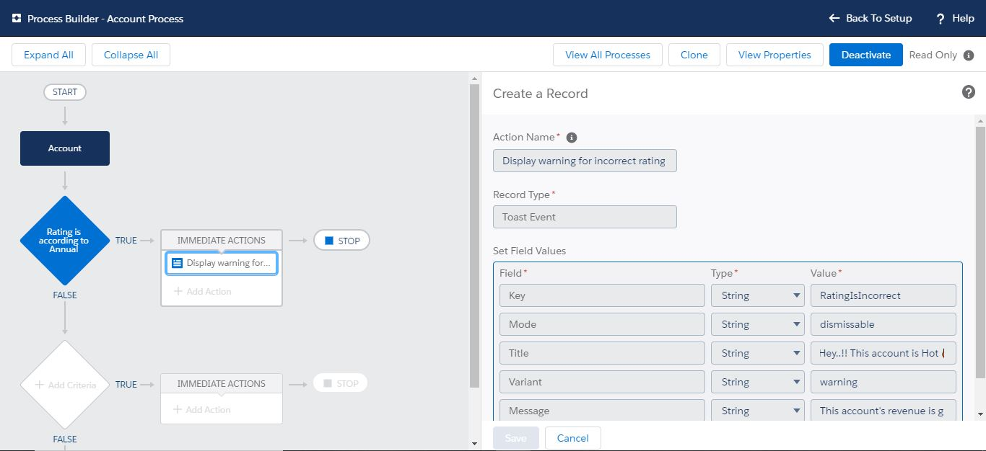  
  
Note:- **Key** is a required field and must be filled. A key is used to uniquely identify a toast event when it's displayed on a page. Moreover, it'll help you as an admin to debug and find the process builder very easily if you're setting up the key as:- **ProcessBuilderName_ConditionName** as a key should be unique.  
  
Once your process builder is ready and activated, it's time to add our component to the lightning page. We just have to make sure that we're adding the same key here as we specified in the process builder:-  
  
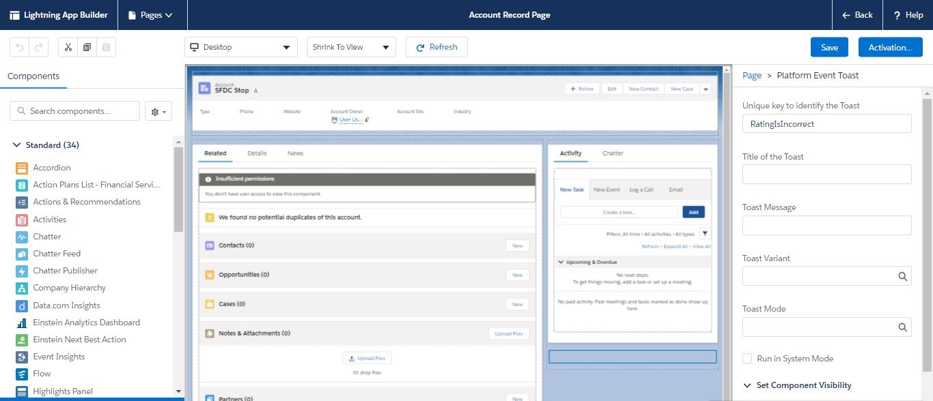  
  
We can leave the other fields empty for this toast as we've setup everything from the process builder. In case, we haven't specified value of other fields in the process builder, we can fill those fields here. **Note that if you've added values in the process builder and in the component as well the values from process builder have higher priority and will override the values set in the component.**  
  
Once you've setup the toast successfully, you'll see the below result when Account's **Annual Revenue >= $50,000 and Rating != Hot**  
  
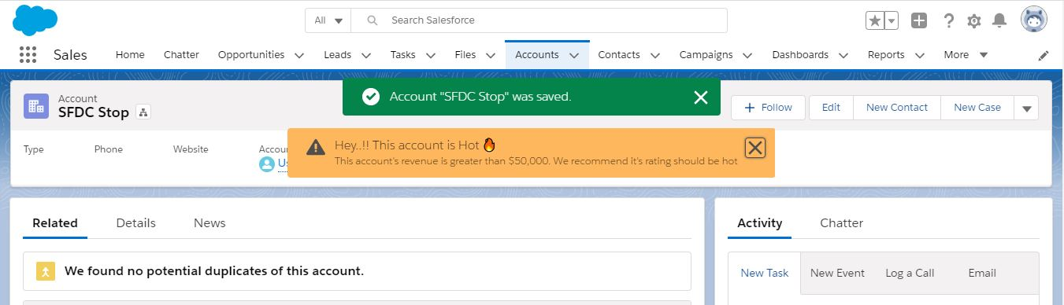

**Example-9:** Batch Job Notifications (Success or Failures)

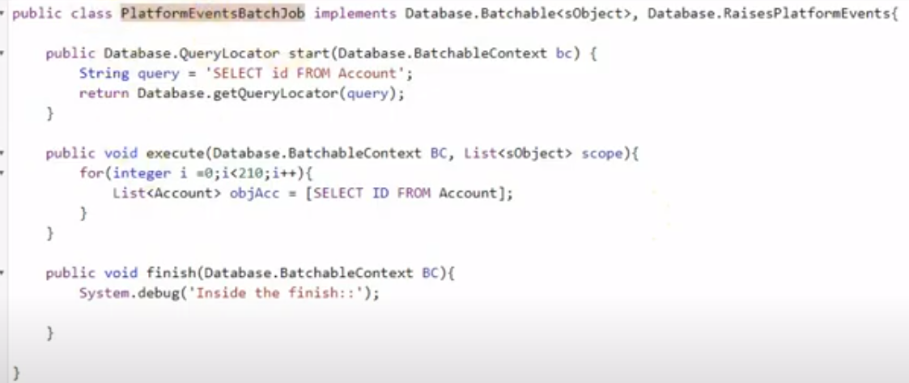

**Example-10:**

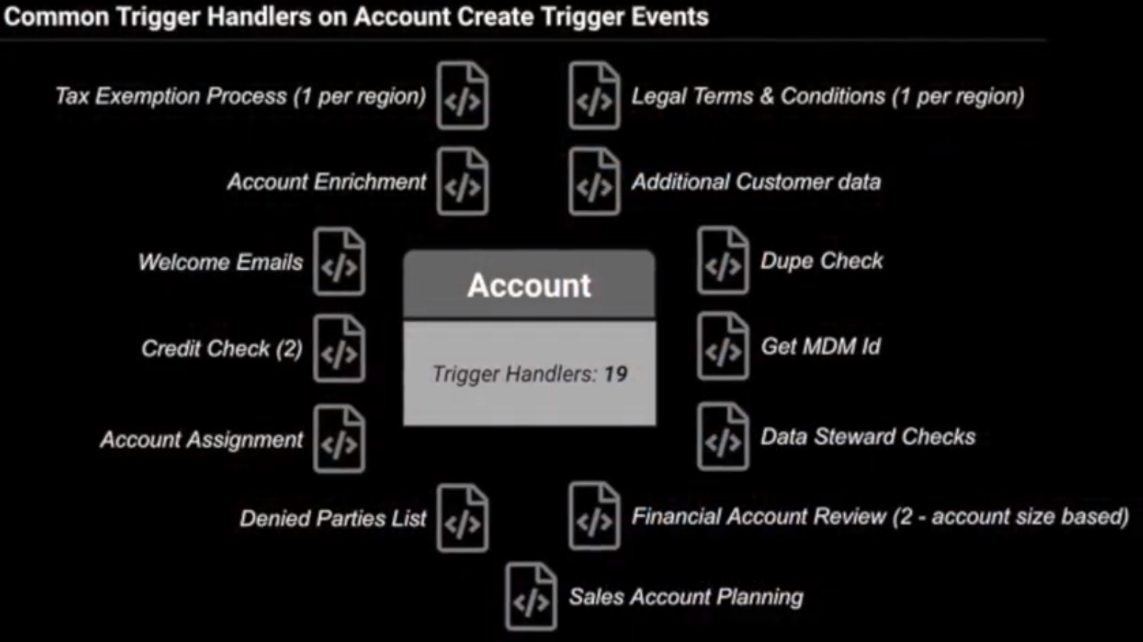

How do we solve this tight coupling with several trigger handlers?

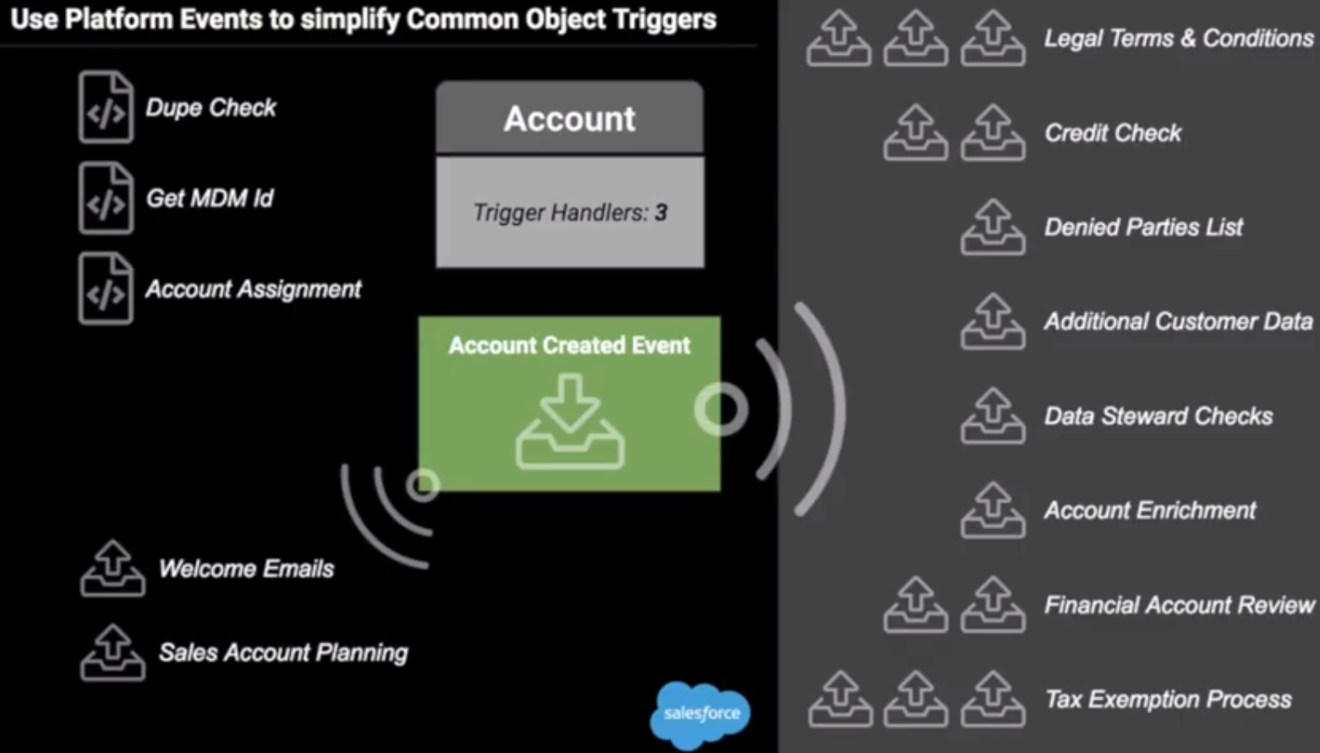

**Example-11**

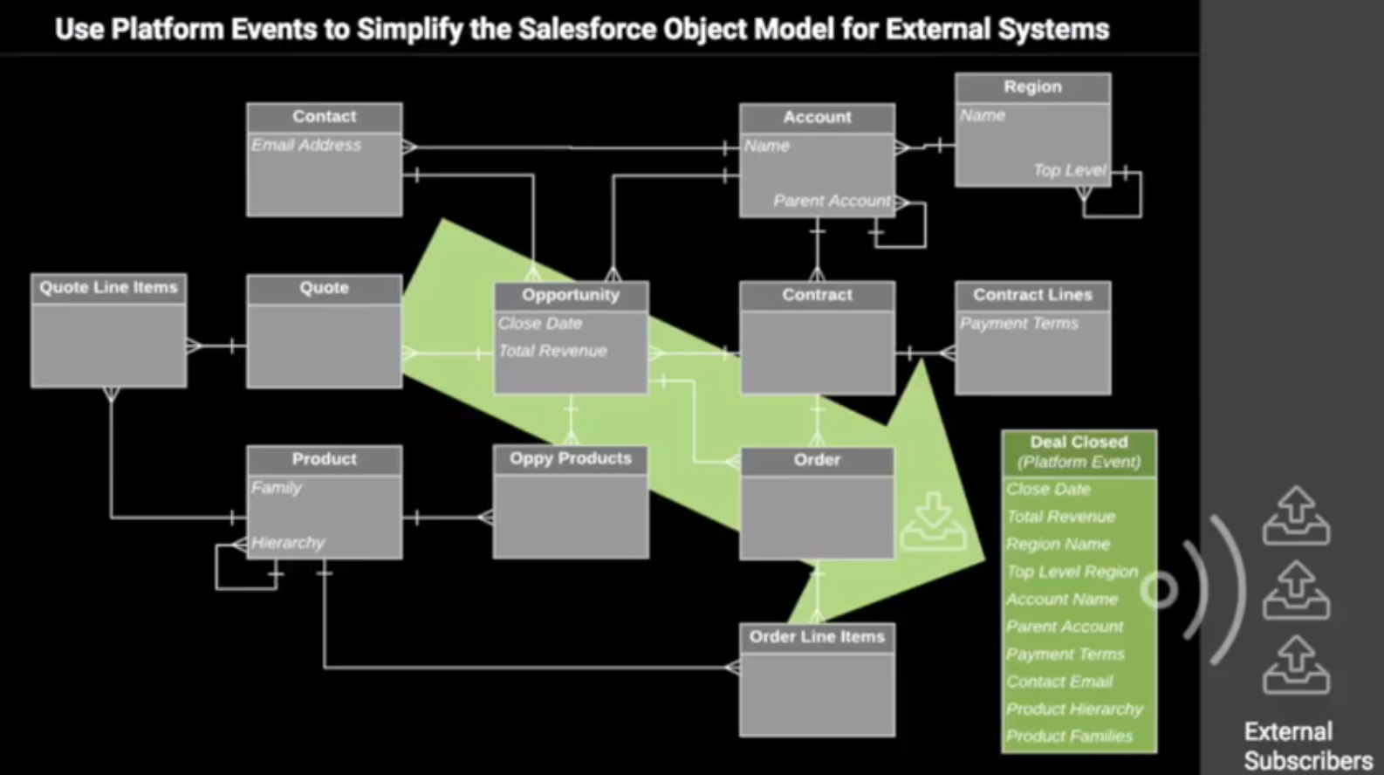

**Example-12:** Lightning Components Communication

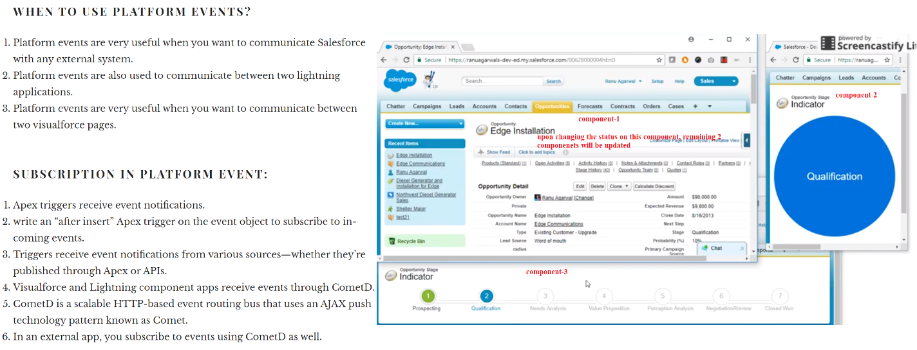

**Example-13:** Send notifications to external systems

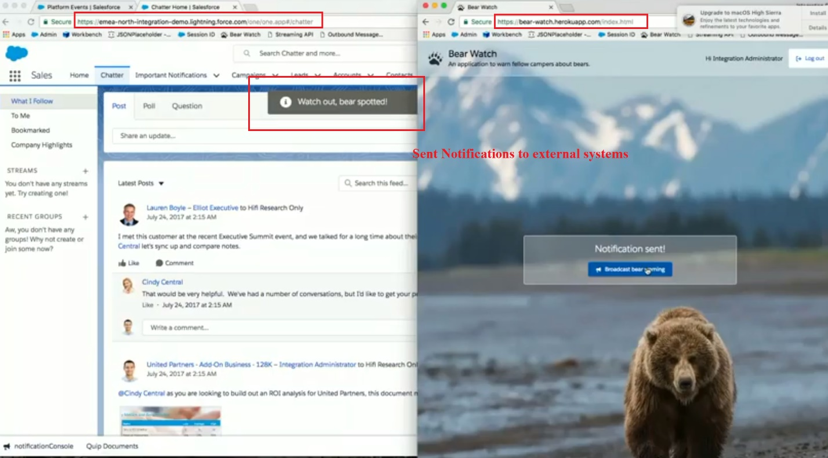

**Example-14: Using Platform Events for Exception Handling**

Create a platform event -

1. Go to Setup > Integrations > Platform Events
2. Create a new event Error Log
3. Specify custom logging fields you want to capture

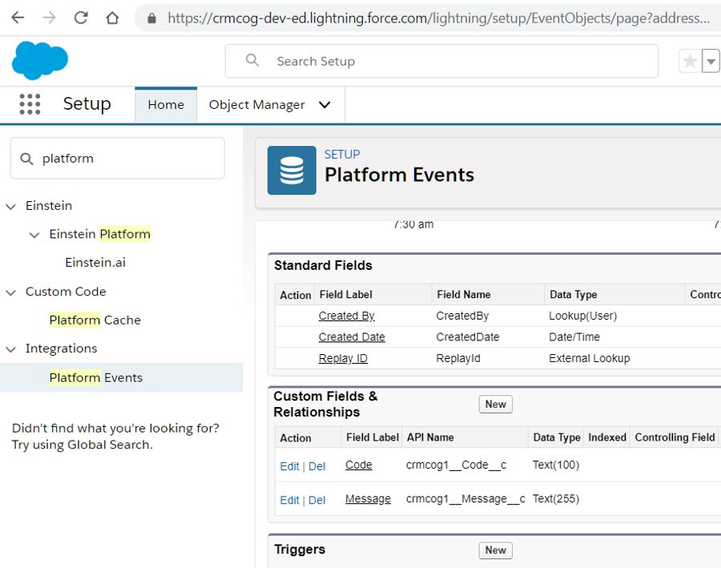

Next, invoke this platform event from custom code -

Id inAcctId = '0011J00001mZTMsQAO';

try {

Integer someNum = 1;

if (someNum == 1) {

throw new IllegalArgumentException('I err ' + Datetime.now());

}

}

catch (exception e) {

System.debug('message: ' + e.getMessage());

List<crmcog1__Error_Log__e> errLog = new List<crmcog1__Error_Log__e>();

errLog.add(new crmcog1__Error_Log__e(Message__c=e.getMessage(), Code__c='42'));

List<Database.SaveResult> res = EventBus.publish(errLog);

throw new IllegalArgumentException('I err in err ' + Datetime.now());

}

Subscribe to this event in Work Bench to see the message -



You can use the platform event to create records in custom object, log messages to Chatter, or do anything else as you please.

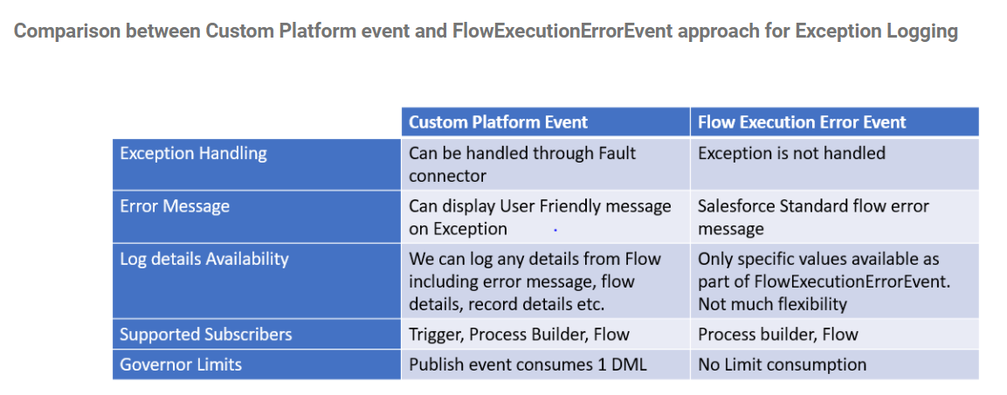

**Example-15**

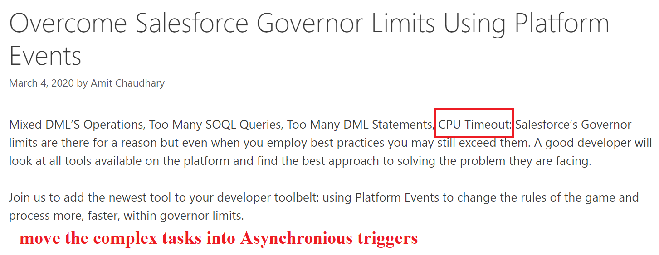

**Example-16:**

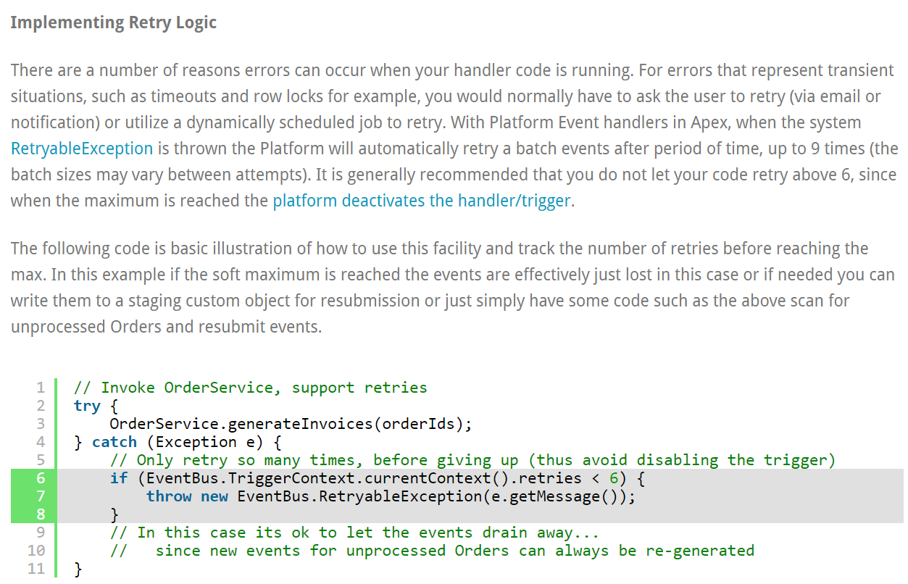

**CHANGE DATA CAPTURE EVENTS**

